H-1B Questionnaire Form

Sr.  no | Particulars | Details
1 | Employee Code | 016739
2 | Employee Name  (as per passport) | Rajasekhar Hasti
3 | Visa Type  (H1B extension/  H1B Amendment  H1B cap exempt/  H1b Extension+Amendment) | H1B Extension
4 | Client name-I  (Client sites where beneficiary will work in the U.S.) | Janus Henderson Investors
5 | Work Location- I  (write full address including city name, state and zip code) | 151 Detroit Street
5 |  | City: Denver
5 |  | State: CO
5 |  | Zip code: 80206
6 | Client name-II  (Client sites where beneficiary will work in the U.S.) | Work from Home for Janus Henderson Investors
7 | Work Location- II  (write full address including city name, state and zip code) | 870 Elmsbrook Lane
7 |  | City: Alpharetta
7 |  | State: GA
7 |  | Zip code: 30004
10 | Annual Base Salary  (to be filled by immigration team)
11 | Job title/Designation (USA) | Senior Computer Programmer Analyst -||
12 | Name & Designation of Manager/ Supervisor in the US | Rahul Parab
13 | Proposed date of commencement of job  (applicable only for Cap exempt not applicable for amendment and extension)
14 | Premium / Regular processing of case  (for premium we need explicit approval from GM/DH) | Premium
15 | At which Consulate will the beneficiary apply for the visa? (Nearest consulate location to your India Work location. This is mandatory to notify which consulat you will apply visa whenever you leave US)  Pune, GOA, Nagpur employees :Mumbai  Hyderabad : Hyderabad  Bengaluru : Chennai | Hyderabad
16 | Visa type (Self/Self dependents) | Self
17 | I94 Expiry date | 14-Aug-2019

Project Name: Global Client Onboarding and Engagement

SHORT PARAGRAPH ON PROPOSED PROJECT:

CLIENT NAME: Janus Henderson Investors
Janus is a leading global active asset manager by helping clients to achieve their long-term financial goals. Janus active management offers clients the opportunity to outperform passive portfolios over the course of market cycles. Janus aims to do this by taking on appropriate levels of risk and offering products and strategies at reasonable fees. Janus takes investor capital and put it to work in different investments including stocks, exchange-traded fund (ETF), bonds, private equity, and more. They handle investments according to an internally-formulated investment mandate, or process.
Janus has embarked on a strategic multiyear digital transformation journey to revamp their organisation processes and enterprise IT systems to keep up with changing market needs and to continue to maintain competitive advantage in the future.
Janus has chosen APPIAN (https://www.appian.com) as the platform for their digital transformation journey to build the next generation IT systems. APPIAN is a market leader in iBPM, Case Management and low code space and have been recognized as such by Forrester and Gartner. Appian’s low-code platform enabled Janus to turn their innovative ideas into high impact business applications up to 20 times faster. Find out how low-code powers enterprise digital transformation in Forrester and Gartner reports.
Persistent Systems Inc. has been an APPIAN partner for over a decade and has extensive experience implementing APPIAN projects across different clients across different industries.
Senior Computer programmer Analyst (Rajasekhar Hasti) from Persistent Systems with expertise and subject matter expert in Appian BPM Suite, Java,JEE, Cloud computing, Database, Architecture are helping Janus Henderson Investors in their digital transformation journey.
SHORT PARAGRAPH ON PROPOSED PROJECT:

Janus current independent onboarding processes involve a large number of internal teams and a combination of systems and spreadsheets. As Janus continues to evolve, the presence of bifurcated processes for onboarding creates inefficiencies and operational risks that could significantly impact client experience and introduce reputational risk.
The need for a single global client onboarding and engagement model was identified. Janus needs a single system that facilitates the process to ensure that:
- Appropriate approvals – CAM/AEM, Distribution Signoff, Secondary signoff are clearly defined for business lines and regions across the globe.
- Ability for Client Account Manager (CAM) and Account Event Manager (AEM) to initiate client onboarding across the globe.
- Availability of account details is centralised in order to streamline the operational setup process involving both internal teams across the organisation, as well as third parties such as BNP.
- Visibility and tracking of onboarding status is provided.
- Consistently excellent client onboarding experience is delivered regardless of region.
- To hold onboarding in case further information about the client is needed
A member of the CAM/AEM group can begin a client on-boarding by accessing the “Actions” tab and choosing “Start Client On-boarding” from the drop-down.
This task contains the following tabs:
- Client Details - This task contains key required fields the CAM/AEM must complete in order to begin on-boarding. For initial design, all fields will be manually inputted by the user. As development continues, some fields may pre-populate from Salesforce.
- Documents – Tab containing document upload grid for user to upload documents and also displays any previously-added documents. Document types include “Agreement – Draft,” “Agreement – Final,” and “Supporting.” Also include a “Description” field.
- Comments – Displays the comments entered previously and allows the user to add a comment
- Select Teams - The purpose of this tab is to allow the CAM/AEM to identify the team(s) that will partake in the Agreement Review Process (and eventually the On-boarding Setup Process). The CAM/AEM will identify a date they want approvals completed by and select the teams to send a review task to. Selection of the teams could look as follows, including the ability to “Select all.”
Global Client onboarding program is an effort under the strategic digital transformation effort for the Janus Institutional Business that manages entire asset management portfolios in collaboration with Risk Process Management (RPM) group of Janus.
Key Objectives:
- To ensure delight of onboarding of both internal teams and external customers (Clients) across regions globally.
- Automate manual tasks, redesign current processes and to improve efficiency.
- To improve the operations process in the Institutional business division, asset management division and risk management division and provide a seamless experience to clients/customers.
- To minimize inventory costs including holding cost, selling costs, buying costs by designing state of the art predictive systems on APPIAN.
- To eliminate late deliveries of critical parts for these divisions.
- Provide a customer (External Customers) self-service portal for ensuring customer delight.
- To provide reports to clients across globe on how their portfolios are managed
The Global client onboarding will enable asset managers - Client Account Manager (CAM) and Account Event Manager (AEM) to initiate onboarding process, view status of approvals, incoming onboarding, take actions like adding additional teams, adjusting client details, approving on behalf of any division, raise red flags and escalate and track late outstanding/pending approvals and automatic co-ordination with business team to ensure timely deliveries.
The Global client onboarding will enable in predictive analytics by building models and reports and calling them from APPIAN to determine the lead time and decision to invest in right investment portfolios- stocks ,ETFs bonds on past data to ensure optimum results.
The Global client onboarding will house the customer delight applications by ensuring that their requests are tracked, delivered on time and closed to completion.
Below is the flow diagram outlining the process flow of the Global Client Onboarding application
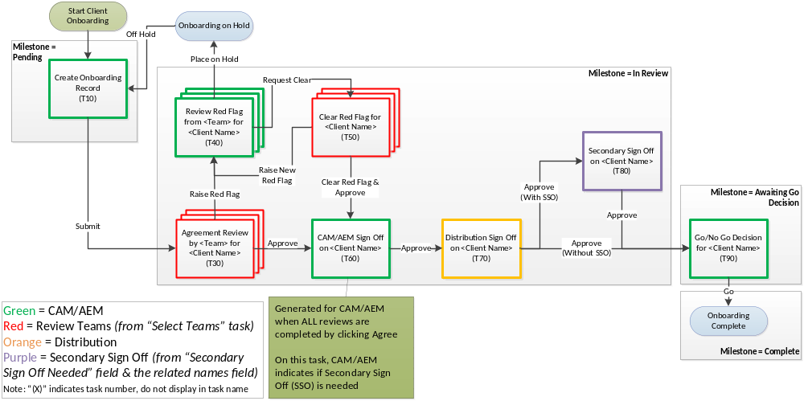

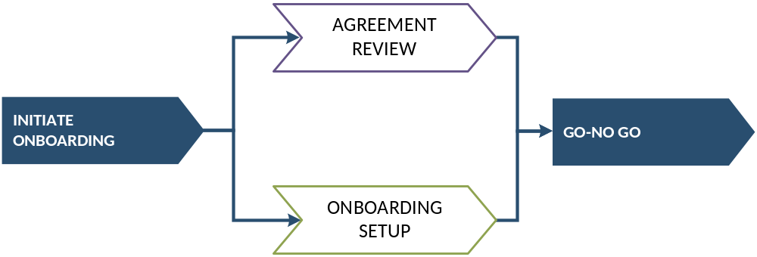

Janus Henderson Investors – Release Plan:
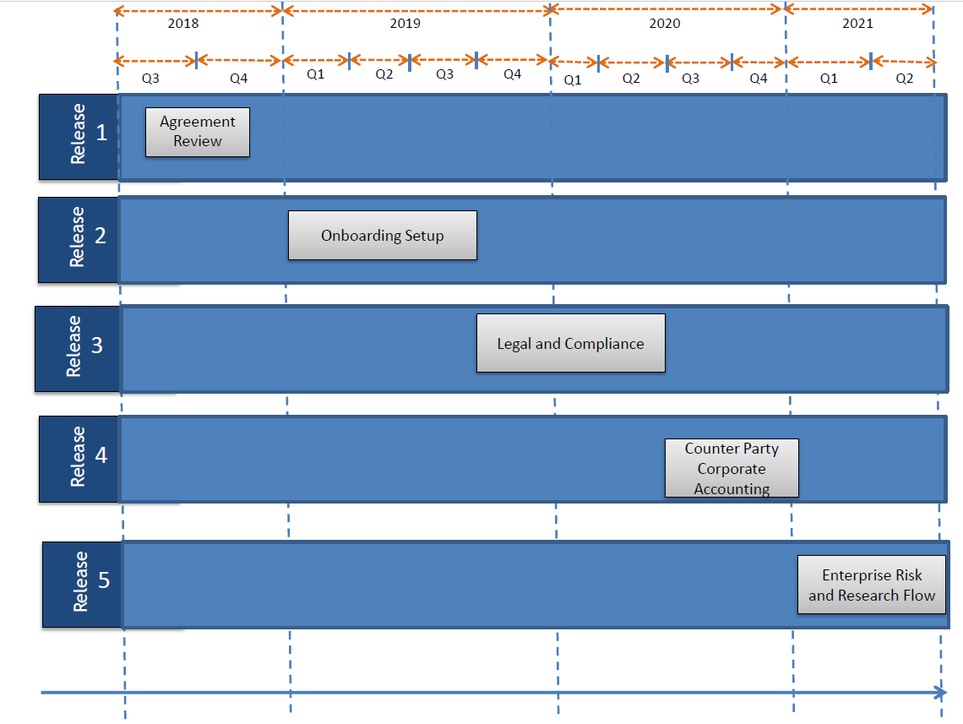
Janus plans to develop this product in different releases for the Institutional clients. This is a high-level plan which will be re-evaluated at the start of every quarter. Based on any changes to project priority, the order in which the projects are taken up might change. The scope and duration of each project might change with additional/removal of requirements. All these changes will be based on consultation with the business and business priority.
Janus plans to develop this product in different releases -
- Release 1 – Agreement Review
- Release 2 – Onboarding Setup
- Release 3 – Legal and Compliance
- Release 4 – Counter Party and Corporate Accounting
- Release 5 – Enterprise Risk and Research Flow

Project Timeline –
- Release 1 – Q3, Q4_2018 - Completed
- Release 2 – Q1, Q2_2019 – Q1 Completed,Q2 - In progress
- Release 3 – Q3, Q4, Q1, Q2_2020 -Planned
- Release 4 – Q3, Q4 2020 -Planned
- Release 5 – Q1, Q2 2021 -Planned

Persistent Systems worked with Janus for developing their repository application called CCAT for Marketing collaterals and projects and also after a successful release of Global Client Onboarding Release 0, Janus has planned to complete the rest of the applications over the course of the next 3 years as detailed in the release plan in collaboration with Persistent systems.
Following will be the key features that are planned to be included in Global Client Onboarding and Engagement (GLOBE) program:
- Agreement Review
- Onboarding setup
- Research Management
- Counter party Management
- Corporate Accounting
- Enterprise Risk
- Legal and Compliance
- Integrations with Salesforce to get inventory data that for Management Information and predictive analysis.
The Global Client Onboarding and engagement solution consists of four technical components -
- APPIAN- Expose and orchestrates the key business process. The different user groups including the administrators and business users will be managed in APPIAN.
- MS SQL Server – Integrate with APPIAN as a primary data source and store the process information.
- SALESFORCE- CRM application which has the master data of the Investment products.
- SHAREPOINT – Document management and storage system to store documents uploaded by users
Key Features: Few key technical features of the Global Client Onboarding developed so far in Release 1 and Q1 of Release 2
  - Single Sign on LDAP authorization at enterprise level.
  - Sales force integration from APPIAN through the APPIAN out of the box connectors.
  - SharePoint integration from Appian through the APPIAN out of the box connectors.
  - Event/Notification handling framework to trigger email and system alerts
  - Add-in deployment to complete the APPIAN tasks within Microsoft Outlook.
  - Predictive analytical and Management Information reports using APPIAN reporting capability
  - Custom plugin development using Java to integrate with their legacy ESB systems to retrieve market data
Profile Summary
- Appian certified lead designer with over 14 years of experience in software design and development on advanced iBPM (intelligent BPM) technologies like APPIAN.
- E2E architecting, design and application development experience on the APPIAN platform including versions 7.10, 16.1,16.2,16.3,16.4,17.1,17.2,17.3,17.4,18.1,18.2,18.3,18.4 and 19.1
- Delivered APPIAN solutions on the Amazon Cloud services (AWS) using the single tenant architecture to ensure robust security.
- Proficient in Java/J2EE design patterns, SOAP & REST services, JSON, XML related languages.
- Experience in working Investment and finance related industries

INFORMATION TO BE FILLED IN BY BENEFICIARY FOR H-1B APPLICATIONS

ALL sections of this form MUST be filled in. Where not applicable, please write N/A.

1 | Surname / Family name / Last name | Hasti
2 | First Name | Rajasekhar
3 | Middle Name
4 | Date of Birth (mm/dd/yyyy) (state “month” in words) | 07/09/1982
5 | Marital Status | Married
6 | Contact Tel Nos. including cell no. | 4255168169
7 | E-mail ID | rajasekhar_hasti@persistent.com
8 | Passport No. | Z2248458
9 | Date of issue of Passport | 02 July 2011
10 | Date of expiry of Passport | 01 July 2021
11 | City/Town of Birth | Tirupati
12 | State/ Province of Birth | Andhra Pradesh
13 | Country of Birth | India
14 | Citizenship | Indian
15 | Are you presently in the US? What status are you in? (e.g. H-1, L-1, B, F, etc.). | Yes ,H1
16 | Are you presently employed with THIS H-1B employer? If yes, please state start date of this employment?  (PSL Joining Date) | June 03 2014
17 | Is this the first time that you are being petitioned for an H-1B by THIS employer? | No
18 | Date of last entry into USA (Applicable only if you are presently in US) | May 04 2018
19 | I-94 # (Applicable only if you are presently in US) | 23489796056
20 | Date of expiry of I-94 (Applicable only if you are presently in US) | 08 / 14 / 2019
21 | EAD card no (A #) ( applicable only if you any such card been issued to you while you were in US)
22 | Date of expiry of EAD card
23 | SEVIS No (If any)
24 | Social Security No (if any) | 058757437
25 | Current residential address in the U.S.  (Provide complete address along with Zip code) | 870 Elmsbrook Lane Alpharetta GA 30004
26 | Residential Permanent Address outside the U.S.(Provide Complete current address along with Postal Code. Not mandatory to have this on your passport) | 20-2-507D1  Korlagunta  Tirupati  517501
27 | At which Consulate will the beneficiary apply for the visa? (Nearest consulate location to your India Work location) For Pune, GOA, Nagpur employees it will be Mumbai, for Hyderabad it will be Hyderabad | Hyderabad
28 | Previous approval notice nos. (if any), along with validity dates, in H or L status
29 | Has a Labor Certification Application been filed for you? If Yes, give date of filing, employer who filed it on your behalf, and the DOL case # if you have it. Please inform us of the status of such a Labor Cert Application. (Applicable only if Green Card process been initiated) | Persistent systems/  A-18092-58116
30 | Has an Immigrant petition, i.e. Form I-140 been filed for you? Has this been approved? If answer to either is “yes” kindly provide any copy of any receipt and/or approval notice for that I-140. (Applicable only if Green Card process been initiated) | Yes, LIN1990069552

Accurate dates of ALL entry and exits into and out of the US, (in H or L status only) in chronological order. (Mm/dd/yy). (Attach all arrival and departure records (stamps) of your passport, entry visa stamps along with passport copy.)

Entry into U.S. | Exit out of U.S. | H/L status
April 5 2013 | August 17 2014 | H4
Sep 14 2014 | Feb 06 2015 | H1B
Mar 08 2015 | Apr 06 2018 | H1B
May 04 2018 | - | H1B

Summaries jobs and duties in percentage format
Job Duties Description

As Senior Computer programmer analyst, he will perform following tasks:

Job Duty | Description | Approximate Time Spent (in %)
Customer Interaction, Leading the Team | - Face of Persistent Systems on our various engagements involving high end supply chain implementations.  - Work hand-in-hand with customers and technical teams to finalize and realize business scenarios.  - Conduct periodic meetings with different teams to discuss progress and roadblocks of the engagement.  - Whiteboard sessions with the client to understand the broad objectives of onboarding process across regions globally  - Elicit the requirements for each of the projects in the pipeline using the deep domain knowledge in the areas of Management Information systems, Management Science and predictive analytics and Database Management systems  - Identify the users and the different roles.  - Identify and map the processes into process maps using MS Visio which can then be implemented in APPIAN.  - Break the requirements into epic stories.  - Break the epic stories into user stories which can then be assigned to developers. | ~ 10 hours every week.  25%
Application Architecture Design | - Design and architecture of the overall product considering the requirements gathered.  - Identify and determine different solutions as to how the architecture can be made more scalable, robust, maintainable, fault tolerant system which not only works in desktop machines but also on different gadgets e.g. Tabs and Mobiles (iPhone, Android, Windows)  - Consider the pros and cons of all approaches and decide on the final approach.  - System integration document (SID) and System architecture document (SAD) which covers important technical components like APPIAN infrastructure, Database design, Authentication mechanism, Authorization Groups and Process Models.  - Leverage knowledge of computer architecture and other subject areas of my expertise to ensure the industry benchmark architecture and design.  - Review design to ensure it incorporates the best practices of APPIAN. | ~10 hours every week  25%
Application Development and Unit Testing and Deployment | - Utilize the past programming knowledge tackle challenging issues in a creative way.  - Ensure the best practices of APPIAN are followed.  - Ensure the processes are developed by incorporating the best quality tools like six sigma, and agile methodologies.  - Create dynamic user interfaces for mobile and desktop.  - Implement dashboard and report for the higher management. Utilize subject expertise gained through subjects like Management Science (MS) and Management Information Systems (MIS) for business intelligence to transform data into meaningful insights.  - Maintain the packages in an external repository.  - Ensure data is moved across environments using database scripts.  - Validate and sanity check target environments after each deployment.  - Utilize the subject matter expertise in Software engineering to ensure high quality software application.  - Review code of the entire team working on the project to ensure that it’s of highest quality.  - Write unit tests of the developed functionality.  - Perform performance testing of processes and User interface using performance view of the SAIL forms and running the health check.  - Conduct System integration testing of application integrating with third party systems to ensure proper handshake.  - Help the client in the user acceptance testing.  - Ensure the application is delivered with 0 defects and is of the highest quality. | ~10 hours for every week  20%
Team Management and Communication | - Track team’s daily status of the assigned tasks, backlog items, mitigating any major issues, Sprint planning and tracking.  - Status update to product owner and discussion and clarification with him in case of any doubts regarding requirement raised by team members | ~5 hours every week  20%
Miscellaneous/Mentoring Team | - Weekly demo using WebEx of incremental product developed on the APPIAN platform.  - Get feedback from the client and incorporate the feedback into the application developed.  - Get sign off the user stories once completed.  - Track the completion of user stories and ensure the project is completed on time and with high quality using tools like JIRA  - Share the project technical documentation in confluence  - Ensure if any production related issues in existing applications are fixed on priority so that no business impact. | ~5 hours every week  10%

